Hey Kinan,
In my previous email I discussed why an AI Agency is the best path for most people to get to 10k a month fast.
But that leaves a question that I probably get asked most:
“What niche should I sell to?”
The truth is, there is no right or wrong here. It’s nuanced.
The first question I ask when this question comes up is: what’s your background?
Because this often points to your unfair advantage.
Do you already know the pain points, the ins and outs of a specific industry or department?
AI will touch every business, every department and every job.
So if you can combine your specific domain expertise in an industry with AI:
You’ve found your Niche.
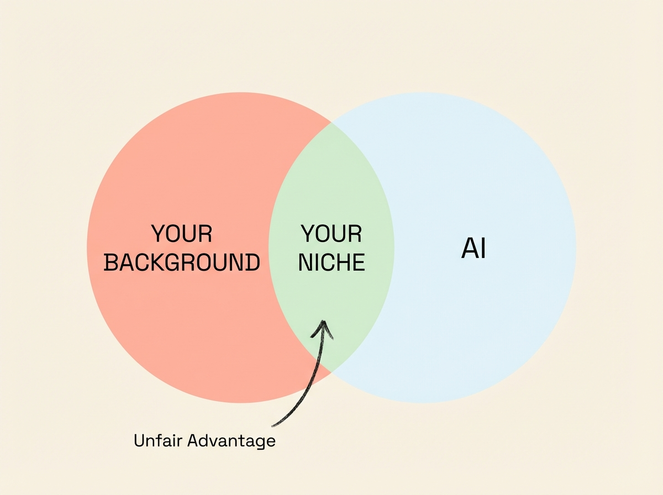
That being said, there are two exceptions to this rule.
The niches you want to avoid when starting.
When you get started you want to avoid two things:
- Large enterprises
Why: long sales cycles, requires expertise & teams.
- Compliance heavy industries / processes
Why: we want to learn fast, not learn HIPAA or GDPR rules.
So if your background is in an industry with the above characteristics, or you don’t have specific domain expertise, or your domain expertise is technical, you will usually have to take a different approach.
How to pick a Niche
In the last two years, I’ve received over 2,200 inbound leads and implemented AI in more than 100 businesses.
So we’ve learned a lot about niches that are better suited for AI Agencies.
The formula that usually works to find a good beginner niche for AI Agencies:
High Labor Costs x Fragmented markets x SMBs = Good Beginner AI Agency Niche.
Why?
High labor costs means high ROI on Automation.
A fragmented market means it’s easier to enter. We don’t want to enter a market that is 90% controlled by 50 large companies (e.g. Supermarkets, Airlines, Telecom, Oil companies).
And when you are starting, you need to optimize for speed & experience. We need to target smaller businesses so we can talk to the founder/business owner directly, shorten sales cycles and implement “simpler” automation systems.
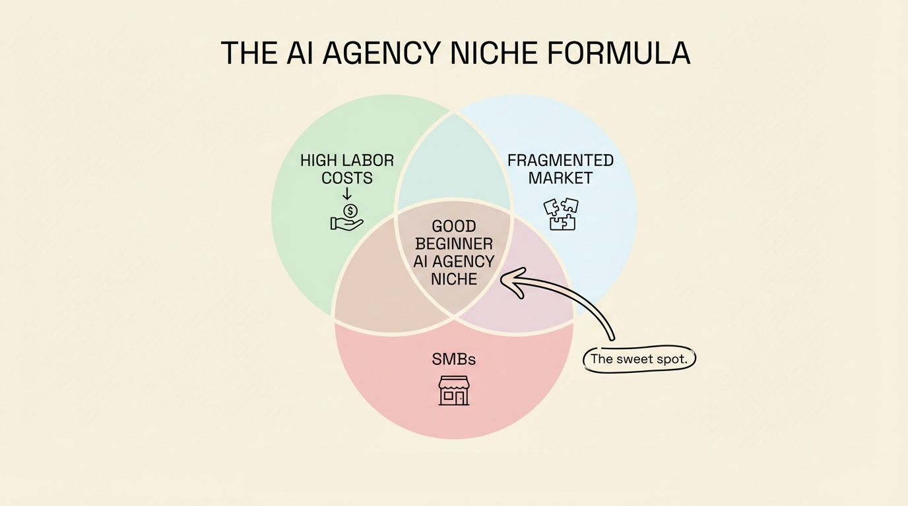
5 Industries we worked with most.
Based on our AI agency clients, here are 5 industries that are great initial targets for your Agency and follow the above formula.
Remember these are not the only ones, but can give you an initial idea.
1. E-Commerce
This is a massive $7 trillion market, yet it is highly fragmented with over 28 million stores. Even the best stores operate on thin net margins (often under 20%) due to the high cost of goods and ad spend.
Why it works:
- Because margins are so thin, a small efficiency gain from AI creates a massive jump in profit.
- Founders here are generally marketers, not "tech people," they need outsiders to build the tech.
- They operate on high volume/low ticket models, meaning high ROI on automation.
How to reach them: They live online. YouTube content showing specific E-com automations works incredibly well (my videos from 6 months ago still bring leads). Also, look for "Partner Programs" with platforms like Shopify to generate inbound leads.
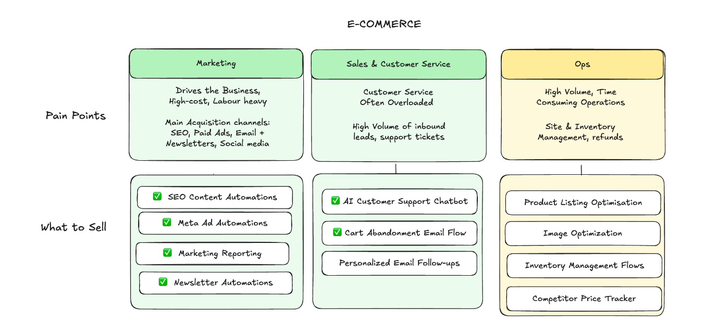
2. Marketing Agencies
A $450 billion market, which is almost the size of the entire software market. There are around 400,000 agencies drowning in "fulfillment" work. Marketing Agencies have been our go-to target for our SEO system.
Why it works:
- This is a labor-intensive business model. They have repeatable digital workflows but rely on expensive headcount to deliver them.
- They are "AI Early Adopters." They aren't scared of AI. The contrary: they are actively looking for it to give them an edge.
- If you automate their delivery, you directly improve their bottom line.
How to reach them: Content is king here. They are constantly on LinkedIn and YouTube looking for trends. Cold outreach also works well because their emails are public and easy to scrape from databases like Apollo.
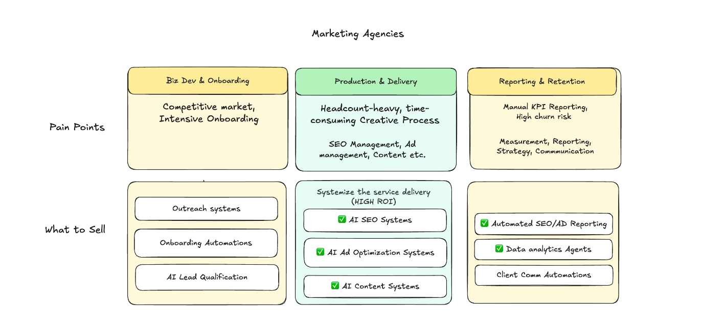
3. Recruitment & Staffing
A $900 billion industry with 160,000 agencies. This is a high-stakes sales game where placing a single executive candidate can earn an agency $20k to $40k in fees.
Why it works:
- The ROI is extremely clear. If your automation helps them place just one extra candidate a year, the system pays for itself ten times over.
- They are burdened with repetitive, high-volume workflows (screening resumes, outreach) that are perfect for AI, yet they are typically non-technical people.
How to reach them: Recruiters live on LinkedIn; it is their office. Cold outreach on LinkedIn or niche-specific YouTube content (which is currently still untapped) works well.
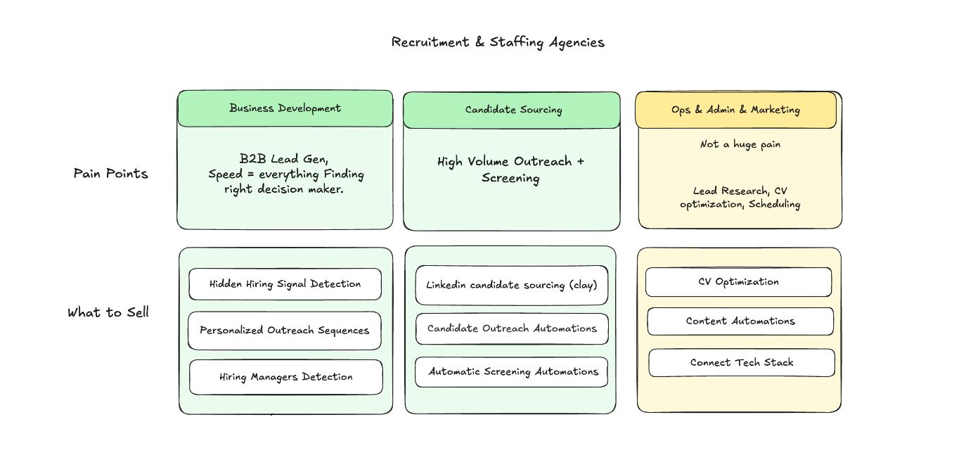
4. Medical/Dental Businesses
A gigantic, highly fragmented industry that has largely been untouched by the SaaS Era. These are legacy businesses often running on old software, dealing with staff shortages, which rely on phone calls and manual processes for revenue.
Why it works:
- Every missed phone call is a lost client. If a receptionist is busy or the business is closed, that money walks out the door.
- They have high labor costs for admin staff and are desperate to modernize but don't know how.
How to reach them: They are not online. Cold calling is the best bet. But if you don’t like cold calling (nobody does, but it works), you can scrape google maps for emails, do form outreach or partnering with the software vendors they already use can be good strategies.
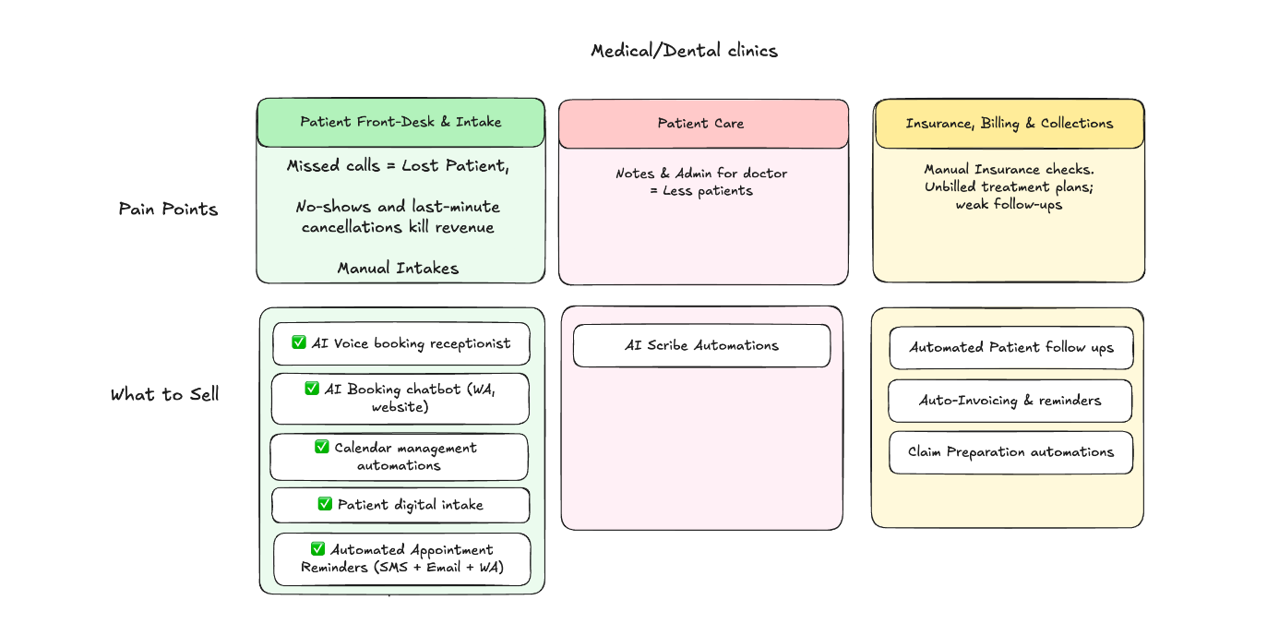
5. Legal Services
A massive $1 trillion market. While big law tech gets the headlines, there are 400,000 small and mid-sized firms that are largely ignored by big tech.
Why it works:
- Lawyers charge high hourly rates ($300+). Every hour they spend on non-billable admin work is literally costing them hundreds of dollars.
- The math is simple for them: if you save them admin time, they can bill more hours.
How to reach them: They are skeptical buyers who rely on reputation. "Hype" marketing fails here. Educational content on LinkedIn, webinars, and building a "Referral Flywheel" (where one happy lawyer refers you to their network) is the winning strategy.
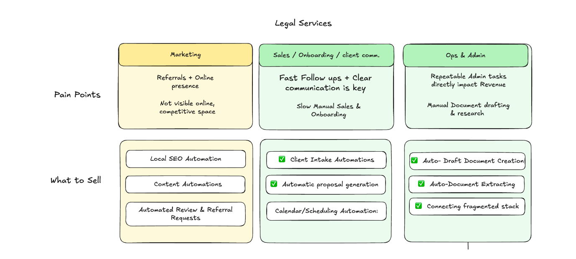
The takeaway
Don’t overthink your niche. Your niche is not set in stone, I’ve changed niche and positioning four times since starting.
You need to get started, learn, iterate and adapt. That’s how you grow the business.
Just pick one. Do the research. Start building.
If you want the templates we use to deliver to these industries, check out my AI Accelerator and get 100+ automation templates, unlimited 1:1 coaching and customer acquisition playbooks.
Let's go after it,
Ben
From Ben AI
https://www.benai.co/accelerator?utm_source=convertkit&utm_medium=email&utm_campaign=The%20right%20niche%20for%20you,%20%7B%7B%20subscriber.first_name%20%7C%20default:%20%22right%20now%22%20%7D%7D%20-%209207623

