Strategic Pricing Intelligence & Market Fit Report: AI-Powered Social Media Services for Sydney Tradespeople
1. Executive Summary
1.1 Strategic Market Context
The digital marketing landscape for Sydney’s trade services sector—comprising electricians, plumbers, HVAC technicians, and builders—is currently characterized by a severe structural polarization. This report identifies a significant "Missing Middle" in the market, creating a distinct opportunity for an AI-powered, "Done-For-You" (DFY) content service. The incumbent market is bifurcated between high-touch, high-cost boutique agencies that charge monthly retainers ranging from $2,000 to over $4,500 ¹, and low-cost, high-effort DIY solutions or offshore virtual assistants that demand significant management oversight from time-poor business owners.³
For the Sydney-based tradesperson, the primary barrier to adoption is not price elasticity but rather trust and time utility. The sector is currently suffering from "scam fatigue," driven by a proliferation of predatory long-term agency contracts, "fake tradie" lead generation schemes, and low-quality offshore outreach.⁵ Consequently, the successful launch of an AI-powered service in this market requires a pricing strategy that functions primarily as a risk-reversal mechanism.
The strategic imperative is to leverage Artificial Intelligence not merely to undercut competitor pricing, but to fundamentally alter the cost structure of content production. By reducing the marginal cost of content creation to near zero, your service can offer agency-grade consistency at a price point that sits comfortably within the discretionary spending power of a small trade business ($500–$1,000 per month), effectively democratizing access to professional digital reputation management.
1.2 Core Findings and Economic Reality
Research into the economic profile of Sydney trades reveals that while gross revenue can be substantial, net margins are often tight, hovering between 5% and 20% depending on the trade specialization.⁷ A standard agency retainer of $2,000 per month requires a trade business operating at a 10% margin to generate an additional $240,000 in annual revenue just to break even on the marketing expense. This math does not stack up for the vast majority of "Growing Crew" businesses (3–8 staff), which represent the prime target demographic.
Furthermore, the "DIY alternative" is a false economy. With Sydney electricians and plumbers billing between $90 and $130 per hour ⁹, a business owner spending just five hours a week on social media management incurs an opportunity cost of approximately $2,000 per month in lost billable time—far exceeding the cost of a managed service.
The competitive landscape analysis indicates that while "setup fees" are a standard industry practice to cover onboarding friction, they are a major psychological hurdle for tradespeople who view them as "money for nothing." Conversely, the market is shifting away from 12-month lock-in contracts towards performance-based or month-to-month flexibility.
1.3 Strategic Recommendations
Based on the synthesis of competitor data, economic constraints, and behavioral psychology, the following strategic pillars are recommended:
- Adopt a Tiered Hybrid Pricing Model: Position the service between the "cheap" offshore perception and the "expensive" local agency. The optimal "Hero" price point is $850 + GST per month, which provides sufficient margin for high-quality AI oversight while remaining below the psychological $1,000 threshold.
- Eliminate Lock-In Contracts: Use liquidity as a trust signal. By offering a month-to-month service, you immediately differentiate from the predatory contracts that plague the industry, shifting the risk from the client to the provider.
- Implement a "Cost-Recovery" Setup Fee: Avoid high setup fees ($1,000+). Instead, charge a nominal fee ($299–$499) that covers the technical integration of AI agents but is low enough to be approved without a complex procurement decision.
- Market "Digital Credibility" over "Lead Gen": To avoid the high churn associated with pay-per-lead models, position the service as essential infrastructure for reputation management and conversion rate optimization, rather than a direct faucet for cold leads.
1.4 Competitive Positioning Overview
The market analysis reveals three distinct competitor clusters: High-Cost Agencies, Low-Cost DIY/SaaS, and Offshore Freelancers. Your AI-powered service occupies a "Blue Ocean" quadrant defined by high service levels (DFY) and mid-range pricing. Unlike agencies that rely on manual labor and high overheads, or DIY tools that rely on the client's labor, your model leverages technology to deliver high-fidelity outputs with minimal client input. This positioning allows you to offer the consistency of an agency with the agility of a SaaS product.

2. Macro-Economic Landscape of Sydney Trades
To determine an optimal pricing structure, one must first deeply understand the economic engine of the target customer. A pricing strategy that is disconnected from the cash flow realities, margin pressures, and operational rhythms of a Sydney trade business is destined to fail.
2.1 The Economic Tiering of Trade Businesses
The term "tradie" is often used as a monolith, but economically, the Sydney market is segmented into three distinct classes, each with unique sensitivities to pricing and value.
2.1.1 The Sole Trader ("Man in a Van")
This segment comprises the single operator, perhaps with an apprentice. Their annual revenue typically spans $150,000 to $300,000. For this demographic, every dollar spent on marketing is a dollar taken directly from their personal household income.
- Economic Reality: Cash flow is volatile and tied directly to their physical presence on job sites. They do not have a "marketing budget" in the corporate sense; they have a "wallet."
- Pricing Sensitivity: Extremely High. They are accustomed to free word-of-mouth referrals or low-cost transactional lead sources like HiPages. A recurring monthly retainer of $500+ is a significant psychological hurdle unless they are in a desperate growth phase.
- Fit for AI Service: Low to Moderate. This segment is best served by a low-cost, automated "entry" tier, as they lack the project volume to sustain a high-frequency content strategy.
2.1.2 The Growing Crew (3–8 Staff)
This is the "Sweet Spot" for your service. These businesses generate between $800,000 and $2.5 million annually. They have moved beyond the "tools" to some extent and are focused on logistics, payroll, and keeping the pipeline full to feed their crew.
- Economic Reality: They have fixed overheads—wages, vehicle leases, insurance. A plumber or electrician salary in Sydney ranges from $75,000 to $90,000.¹¹ The business owner is under constant pressure to generate work to cover these costs.
- Pricing Sensitivity: Moderate. They are willing to pay for solutions that save time. They understand the concept of "business expenses" and likely have a small budget allocated for growth (typically 2-3% of revenue, or $20k–$50k p.a.).¹²
- Fit for AI Service: High. They are too small to hire a marketing manager (costing $80k+) but too big to rely solely on word-of-mouth. They are currently overpaying agencies or neglecting marketing entirely.
2.1.3 The Established Firm (10+ Staff)
These are structured companies with revenues exceeding $3 million. They often specialize in high-end commercial contracts, strata management, or luxury builds.
- Economic Reality: Marketing is a line item. They may already have a boutique agency on retainer or a part-time internal coordinator.
- Pricing Sensitivity: Low. They value brand dominance and recruitment power over saving a few hundred dollars.
- Fit for AI Service: Moderate. They require a bespoke, high-touch service that may be difficult to fully automate without significant human-in-the-loop oversight.
2.2 Profit Margins and the "Break-Even" Calculation
Understanding the profit mechanics of Sydney trades is crucial for framing the Return on Investment (ROI) of your service. The construction and trade sector is known for high turnover but relatively thin net margins.
- Net Margins: Research indicates that average net profit margins for building and construction businesses fluctuate around 5%.⁸ Specialized trades like plumbing and electrical may see slightly healthier margins of 8% to 20% ⁷, but they are still constrained by rising material costs and labor shortages.
- The Implications for Pricing: If you charge a builder $1,500 per month ($18,000 per annum), and their net margin is 5%, they must generate an additional $360,000 in gross revenue—roughly the cost of a small home extension or several major renovations—just to cover the cost of your service.
- Strategic Insight: This mathematical reality is why many tradies cancel agency contracts. The "Lead Gen" agency promises the world but delivers low-quality leads that don't convert, leaving the tradie with a bill that eats their margin. Your AI service must be priced and positioned differently. Instead of requiring massive new revenue to justify itself, it should be priced so that it can be covered by the margin of one or two standard jobs per month. For a plumber installing hot water systems (a $1,500–$3,000 job ¹³), a marketing fee of $800 is covered by the profit from just a handful of installations.
2.3 The Opportunity Cost of Time
The strongest economic argument for your service is not just "making money" but "saving time." In Sydney, the cost of labor is a hard metric.
- Hourly Billing Rates: Electricians and plumbers in Sydney charge between $90 and $130 per hour.¹⁰ Emergency call-outs can attract fees of $150+.⁹
- The DIY Equation: If a tradie decides to "save money" by doing their own social media, and they spend 4 hours a week (writing captions, fighting with Canva, posting), they are consuming 16 hours a month. At a billable rate of $110/hour, the effective cost of their DIY marketing is $1,760 per month.
- Marketing Angle: Your sales pitch should explicitly highlight this arbitrage. "You are paying yourself $1,760 a month to do a bad job at social media. Pay us $850 to do a professional job, and go bill that time to a client."

3. Competitive Pricing Intelligence
The Sydney market is crowded, but the distribution of competitors is uneven. Analyzing the specific offers of local and national competitors reveals where the pricing power lies.
3.1 The Agency Model (High Cost / High Friction)
Traditional digital agencies in Sydney and major Australian cities operate on a high-overhead model (office rents, account managers, sales teams) which forces them to charge substantial retainers.
- Quantum Web: Their packages start from $2,450 + GST per month for content creation (3 posts/week on two platforms).¹ They charge additional hourly rates of $199 for ad-hoc work. This pricing is prohibitive for most small trade businesses.
- JBE Digital: Offers "Setup Packages" ranging from $1,999 to $3,499.² While framed as a "one-off" setup, they attach recurring monthly fees for hosting and management. This model front-loads the cost, transferring all the risk to the client before any value is delivered.
- Resurge Digital: Standard SEO and management retainers start at $1,000 to $1,500 per month.¹⁵ They emphasize that costs vary by "competitiveness," which often leads to scope creep and unpredictable billing for the client.
- Analysis: These agencies are vulnerable. Their high price point creates a "value gap" where clients expect transformative growth. When the reality of organic social media (slow, steady growth) sets in, clients feel short-changed and churn. Your AI model can deliver 80% of this output quality for 30% of the price, effectively disrupting their lower-tier offerings.
3.2 The Volume/Package Model (Commoditized Services)
Some agencies have attempted to commoditize the service to lower prices, often by outsourcing to offshore teams or using strict templates.
- Tradie Marketing Canberra: Offers a $99/week package (~$430/mo) for 2 posts per week.¹⁶ This is a direct competitor to your proposed entry-level tier.
- BeKonstructive Marketing: Charges $960/mo for a "Basic" package of 8-10 posts.¹⁷ This pricing validates the ~$900 price point as a standard market accept for "light" management.
- Soup Agency: Lists "Basic" packages from $500 - $1,500 per month.¹⁸ Their wide range suggests a lack of standardization, likely tailoring heavily to the specific client, which is hard to scale.
- Analysis: These competitors validate that there is a market for <$1,000/mo services. However, their content often suffers from being generic—stock photos of happy families or American construction sites—which damages the authentic "grit" that successful trade brands need.
3.3 The DIY & SaaS Alternatives
The biggest competitor is often "non-consumption" or the business owner doing it themselves using software tools.
- Cost Structure:
- Canva Pro: ~$18/month.¹⁹
- AI Tools (Jasper/Blaze): $40 - $100/month.²⁰
- Scheduling Tools (SocialBee/Hootsuite): $30 - $150/month.²¹
- The Hidden Barrier: While financially cheap, these tools require cognitive load. A tradie tired after 10 hours on site does not have the mental energy to prompt ChatGPT for "engaging captions about switchboard upgrades." The failure rate of DIY is high, leading to dormant pages—a problem your service solves through automation.
3.4 The Offshore Virtual Assistant (VA) Market
Many tradies turn to Upwork or agencies that broker Filipino VAs.
- Pricing: Direct hires from the Philippines cost between $6 and $15 AUD per hour.³ A part-time VA (10 hours/week) might cost ~$400 - $600/mo.
- The "Scam" Perception: There is significant noise in this space. "Fake Tradie" scams and low-quality outreach have made Australian businesses wary of purely offshore solutions.⁵ Issues with cultural nuance (e.g., using "HVAC" instead of "Air Con", or "Faucet" instead of "Tap") signal inauthenticity to local customers.
- Analysis: Your AI service must distance itself from this category. You are not a "VA Service"; you are an "AI Technology Partner" with "Sydney-based Quality Control."

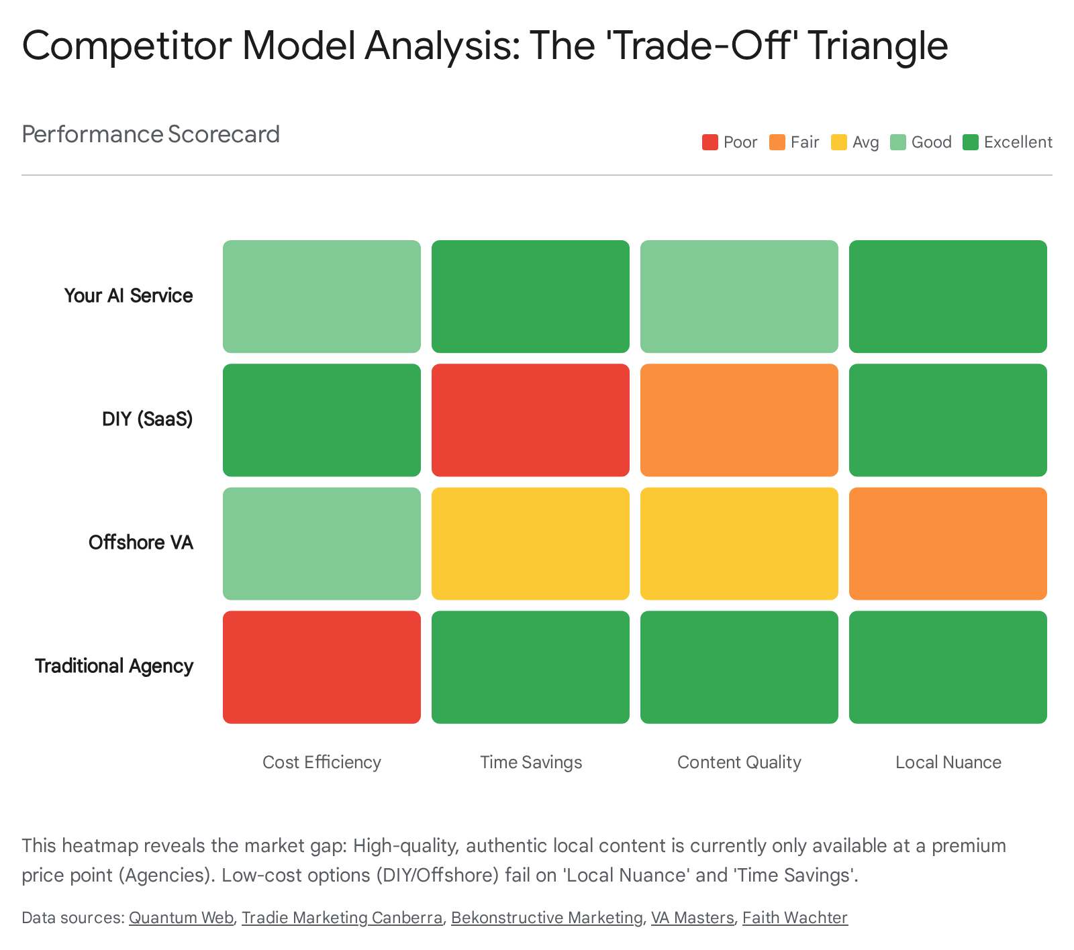

4. Pricing Psychology and Value Perception
Selling to tradespeople requires a specific psychological approach. This demographic is generally pragmatic, averse to corporate jargon, and highly skeptical of intangible services. To price effectively, you must frame your value in terms that resonate with their operational mindset.
4.1 The Trust Deficit and "Scam Fatigue"
The Australian small business sector is currently experiencing a crisis of trust regarding digital services. Reports from the ACCC and Scamwatch highlight the prevalence of "business email compromise," fake invoice scams, and predatory marketing schemes targeting small businesses.⁵
- The "Fake Tradie" Phenomenon: Legitimate tradies are also battling against scammers posing as tradespeople to rip off consumers. This environment makes them hyper-vigilant about who they partner with.
- Impact on Pricing: If your price is too low (e.g., $199/mo), you risk triggering a "too good to be true" scam heuristic. If it is too high, you are lumped in with the "greedy agencies." The pricing must signal legitimacy—accessible but substantial enough to imply quality.
4.2 Value Perception: "Leads" vs. "Brand"
A critical psychological disconnect exists in the market: Tradies generally want "Leads" (immediate phone calls), but social media management primarily delivers "Brand" (trust, reputation, and long-term visibility).
- The Friction Point: When a tradie pays $1,500/mo for social media and the phone doesn't ring in week one, they feel scammed. Agencies often fail to manage this expectation.
- Reframing the Value: Your pricing strategy must decouple the service from the immediate promise of leads. Instead, frame the service as "Digital PPE" (Personal Protective Equipment) for their business reputation.
- The Pitch: "In 2024, if a customer Googles you and sees a Facebook page that hasn't been posted on since 2019, they assume you are out of business or don't care. We ensure you look 'Open for Business' and professional, so when referrals check you out, they convert."
- This shifts the psychological bucket from "Risky Investment" (hoping for leads) to "Essential Maintenance" (like servicing the van).
4.3 The Psychology of Setup Fees
In the agency world, setup fees of $1,000+ are standard to recoup customer acquisition costs (CAC) and fund the initial strategy work. To a tradie, however, a large upfront fee feels like a "profit grab."
- Risk Reversal: High setup fees signal that the client is taking the risk. If the service doesn't work, the client is out of pocket $1,000+.
- Recommendation: A "Cost-Recovery" Setup Fee ($299 - $499) is optimal. It is high enough to filter out non-serious prospects (kick-tykers) but low enough to be approved on a credit card without a rigorous ROI analysis. It should be framed strictly as covering "Technical Integration" (e.g., setting up the AI agents, connecting accounts), which tradies understand as a valid labor cost.
4.4 Payment Models: Evaluating the Options
Different payment structures incentivize different behaviors.
4.4.1 The Fixed Monthly Retainer (Recommended)
- Mechanism: Flat fee per month for a set scope of work (e.g., 12 posts).
- Pros: Predictable revenue for you; predictable expense for the client. Aligns with their other subscription costs (software, phone bills).
- Cons: Client may feel they are paying even when "nothing is happening" (if they don't see the posts).
4.4.2 Pay-Per-Lead (PPL)
- Mechanism: Client pays per inquiry generated.
- Pros: Highly attractive to tradies as it feels "risk-free."
- Cons: High Conflict Risk. Attribution is messy. A tradie might argue "That lead was tire-kicker, I'm not paying." PPL models require you to control the ad spend and landing pages, which adds significant operational complexity and financial risk to your business.²⁴
- Verdict: Avoid for a content-focused service. It creates an adversarial relationship.
4.4.3 Pay-Per-Post
- Mechanism: Client pays only for what is posted.
- Pros: Transparency.
- Cons: Revenue Instability. Clients will inevitably try to "save money" during slow months by cutting post volume, destroying your recurring revenue (ARR). It turns a relationship into a transaction.
4.5 The "No Lock-In" Contract
The traditional 12-month agency contract is a major friction point. In a volatile industry where rain can stop work for a week, committing to a year of payments is daunting.
- Strategic Advantage: Offering a "Month-to-Month, Cancel Anytime" agreement is the single most powerful trust signal you can offer. It implies: "We are so confident our service works that we don't need to trap you."
- Retention Reality: Data suggests that while clients can leave anytime, inertia usually keeps them. If the price is right and the friction is low, they will stay. The "freedom" to leave actually increases retention by reducing anxiety.

5. Strategic Pricing Architecture & Recommendations
Based on the economic constraints and competitive landscape analysis, we recommend a three-tiered pricing structure. This "Good-Better-Best" model allows you to capture different segments of the market while anchoring the value of the core offering.
5.1 The Pricing Matrix
Tier Name | Target Customer Segment | Monthly Investment | Setup Fee | Core Deliverables (AI-Powered)
Tier 1: The "Digital Business Card" (Starter) | Sole Traders / Startups (<$300k Rev) | $499 + GST | $299 | • 2 Posts/Week (Static Image + Caption)  • Google Business Profile Sync (Critical for SEO)  • Monthly automated PDF report  • Goal: Maintenance & Legitimacy
Tier 2: The "Local Authority" (Growth) | Small Teams (3-8 Staff) - HERO TIER | $850 + GST | $499 | • 4 Posts/Week (Mix of Static & Carousel)  • 1 Reel/Week (AI-edited from raw site footage)  • Community Management (AI-monitored comment replies)  • "Review Booster" (Automated SMS review requests)  • Goal: Engagement & Trust
Tier 3: The "Market Dominator" (Scale) | Established Firms ($2M+ Rev) | $1,450 + GST | $999 | • Daily Posting (7 days/week)  • 2 Reels/Week (High production value)  • LinkedIn Management (For commercial contracts)  • Ad Creative Generation (Ads management sold separately)  • Priority Support  • Goal: Market Dominance

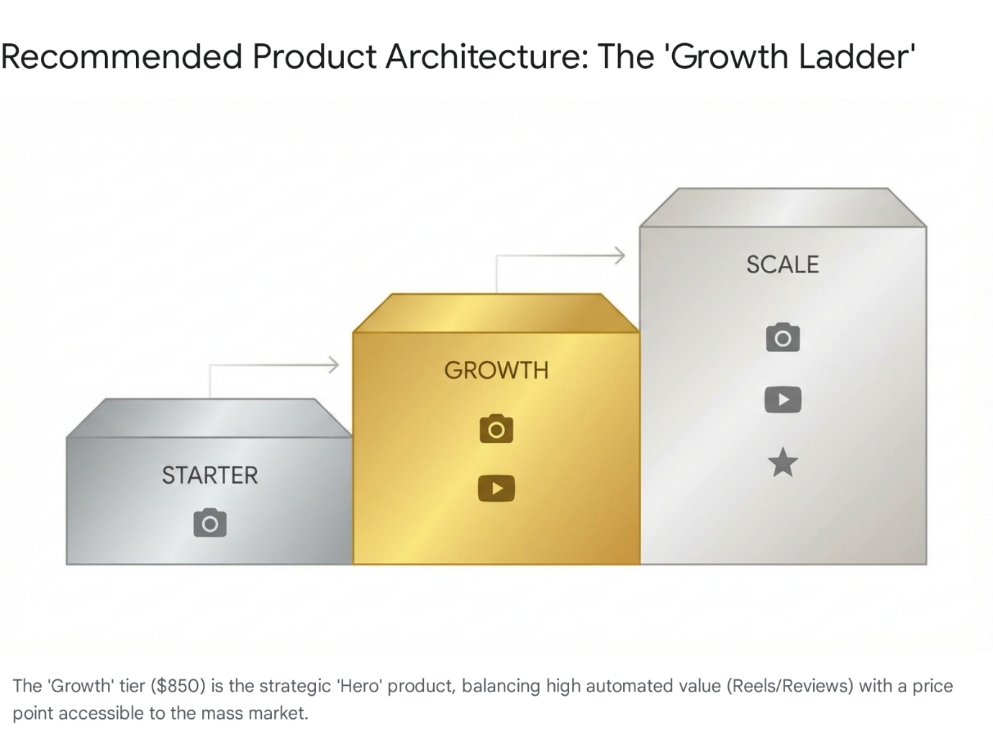

5.2 Rationale for Price Points
5.2.1 The $499 Starter Tier
This price point is strategically designed to compete with the "opportunity cost" of DIY. At $499, it is less than the cost of 4 hours of a tradie's time ($400-$500).
- Profitability: This tier relies on 90% automation. Using AI tools like Predis.ai or Canva Bulk Create, static posts can be generated in batches. The "human touch" time should be less than 30 minutes per month per client, preserving a healthy margin.
- Role: This is an acquisition tool. It gets clients into your ecosystem. Many will upgrade once they see the quality and consistency.
5.2.2 The $850 Growth Tier (The Hero Product)
This is where the business model becomes robust. The inclusion of Reels is the key differentiator.
- Why Reels? Video content is currently favored by algorithms on Instagram and Facebook, offering higher organic reach. However, video editing is incredibly time-consuming for tradies.
- AI Leverage: By using AI video tools (like OpusClip or Submagic) to process raw footage sent by the tradie, you can deliver "agency-level" video content at a fraction of the manual editing cost.
- Review Booster: Including an automated mechanism to request Google Reviews adds a "revenue-generating" component to this tier. More reviews = better local SEO = more calls. This reduces churn because the client sees a direct link to new business.
5.2.3 The $1,450 Scale Tier
This positions your service against the $2,500+ boutique agencies.
- Value Proposition: For larger firms competing for commercial tenders (e.g., strata maintenance, commercial fit-outs), LinkedIn presence is vital. Adding LinkedIn management justifies the price jump, as B2B contracts have much higher value.
5.3 The "Hybrid" Nature: AI + Human Oversight
To justify these prices against $20/month SaaS tools, you must market the service as "AI-Powered, Human Verified."
- The Narrative: "We use AI to keep costs down and speed up production, but a real human in Sydney checks every post to ensure it's accurate, safe, and sounds like you."
- Why it matters: Construction is a high-risk industry. A photo of a worker without a hard hat or a ladder set up incorrectly can attract fines or reputational damage. Pure AI tools cannot identify safety violations; a human-in-the-loop (HITL) model is a non-negotiable safety feature for this vertical.
5.4 The False Economy of DIY
A critical component of your pricing strategy is educating the market on the true cost of the "Do It Yourself" alternative. Many potential clients will initially object, claiming they can "just do it themselves for free." This is a fallacy that must be dismantled during the sales process.
Consider a typical electrical contractor in Sydney. Their billable rate is approximately $110 per hour. To maintain a basic social media presence (3 posts a week, replying to comments, updating their bio), they or their senior staff will spend a minimum of 4 hours per week.
- Weekly Cost: 4 hours x $110 = $440.
- Monthly Cost: $440 x 4.3 weeks = $1,892.
- Annual Cost: ~$22,700 in lost billable revenue.
Even if they assign this task to an apprentice (costing ~$30/hr), the cost is still ~$500/mo, but the quality of the output—and the risk of unprofessional content—is significantly higher. Furthermore, when the business gets busy, the "DIY" marketing is the first thing to be dropped, leading to the "feast and famine" cycle of lead generation. Your service, priced at $850/mo, is mathematically less than half the cost of the owner doing it themselves, while guaranteeing consistency regardless of their workload.

6. Product-Market Fit & Competitive Positioning
Achieving Product-Market Fit (PMF) in this sector requires more than just a pricing strategy; it requires a product that fits seamlessly into the chaotic, mobile-first workflow of a tradie.
6.1 The "Site-Shot" Workflow System
The biggest operational failure point for social media agencies serving trades is content acquisition. Agencies often nag clients for photos, get no response, and then resort to using generic stock photos (e.g., "Man with wrench smiling"), which tradies and their customers despise.
- The Solution: You must build a friction-free intake system. Implement a WhatsApp or SMS bot that messages the client at a strategic time (e.g., Friday at 2:00 PM): "Hey mate, nearly beer o'clock. Snap 2 photos of the job site before you pack up and reply here. I'll handle the rest."
- AI Integration: Your AI system then takes that raw photo, enhances the lighting, identifies the context (e.g., "Installing a Rheem hot water system"), writes a caption using local SEO keywords (#PlumberSydney #HotWater), adds the logo, and schedules it.
- Value: This turns a "chore" into a 10-second task, solving the content bottleneck.
6.2 Positioning: "Infrastructure" vs. "Creativity"
Agencies pitch "Creativity" and "Brand Storytelling." Tradies don't care about storytelling; they care about Competence and Reliability.
- Messaging Strategy: Position your service as "Digital Infrastructure."
- Bad Pitch: "We will tell your brand's unique story to engage your audience."
- Good Pitch: "We build a digital asset that works in the background 24/7. While you are on the tools, we ensure your business looks active, professional, and dominant in your local suburb."
6.3 Hyper-Local Relevance
Generic AI content often sounds American (referencing "faucets," "sidewalks," or "drywall"). Product-Market Fit in Sydney requires Hyper-Localization.
- Execution: Your AI models must be fine-tuned or prompted with Australian specific terminology:
- "Gyprock" not "Drywall".
- "Ute" not "Truck".
- "Switchboard" not "Panel".
- "Safety Switch" / "RCD" knowledge.
- Geography: Content should reference specific Sydney regions. "Servicing the Inner West from Newtown to Ashfield" resonates far more than "Servicing Sydney."

7. Risk Analysis & Mitigation
Launching this service involves specific risks related to the platform economy and the nature of AI.
7.1 Platform Dependency Risk
Relying solely on Meta (Facebook/Instagram) is a vulnerability. Algorithm changes can slash reach overnight.
- Mitigation: Diversify the deliverables to include Google Business Profile (GBP) posts. GBP updates (posting photos and offers to the Google Map listing) have a direct correlation with local SEO rankings. This is a high-value, stable channel that tradies understand ("I want to be number one on Maps"). Ensuring your AI posts automatically sync to GBP creates a "moat" around your service.
7.2 AI "Hallucination" and Safety Risk
AI can generate plausible but factually incorrect technical advice. In electrical or gas trades, bad advice can be dangerous.
- Scenario: An AI generates a caption for an electrician suggesting "DIY switchboard maintenance is easy." This is illegal in Australia.
- Mitigation:
- Strict Prompt Engineering: Use negative constraints in your AI prompts (e.g., "Never suggest DIY electrical work," "Always mention 'Licensed Professional'").
- Human-in-the-Loop (HITL): A human review layer is mandatory. This doesn't need to be a senior marketer; it can be a junior staff member or a retired tradesperson working part-time to "sanity check" the technical accuracy of posts before they go live.
7.3 Churn Risk: The "3-Month Wall"
Data suggests that retention drops significantly at the 90-day mark if the client hasn't perceived value. Since organic social growth is slow, this is a danger zone.
- Mitigation:
- The "Quick Win" Sprint: In the first 30 days, run a "Database Reactivation" campaign. Ask the client for a list of past customers (or export from Xero/ServiceM8) and use an SMS blast to request Google Reviews. Getting 5-10 new 5-star reviews in the first month provides immediate, undeniable value ("You got me more reviews in a month than I got in 5 years") which buys you patience for the social content to build traction.

8. Conclusion
The Sydney trade services market represents a prime opportunity for disruption. The incumbents are either too expensive (agencies) or too difficult to manage (offshore/DIY). By leveraging AI to compress the cost of content production, you can offer a "Third Way": a managed, high-quality service at a price point ($500–$900) that fits the economic reality of the "Growing Crew" business.
Your success will not come from competing on "creativity," but on reliability and friction reduction. By implementing a "Site-Shot" workflow that requires almost zero effort from the tradie, and pricing with a transparent, no-lock-in model, you de-risk the purchase decision and build a scalable infrastructure for digital reputation management. The key is to sell "Time Saved" and "Digital Credibility," solving the two biggest anxieties of the modern tradesperson: being too busy to market, and looking unprofessional when they don't.
Works cited
- Social Media Packages | Social Media Pricing & Inclusions - Quantum Web Solutions, accessed on January 8, 2026, https://www.quantumweb.com.au/social-media-packages
- Digital Marketing For Tradies | Tradie Website & Marketing Packages - JBE Digital, accessed on January 8, 2026, https://www.jbedigital.com.au/digital-marketing-packages-for-tradies/
- How Much Should You Charge as a Virtual Assistant? A Pricing Guide | VirtualStaff.ph, accessed on January 8, 2026, https://www.virtualstaff.ph/blog/how-much-to-charge-as-a-virtual-assistant
- DIY vs. Freelancer vs. Social Media Agency for Small Businesses - MAVRK Studio, accessed on January 8, 2026, https://mavrk.studio/diy-freelancer-social-media-agency-for-small-businesses/
- Fake tradies - Consumer Affairs Victoria, accessed on January 8, 2026, https://www.consumer.vic.gov.au/consumers-and-businesses/scams/fake-tradies
- Unicorn job scams: Criminals target vulnerable Aussies looking for work | Australian Federal Police, accessed on January 8, 2026, https://www.afp.gov.au/news-centre/media-release/unicorn-job-scams-criminals-target-vulnerable-aussies-looking-work
- Improve Your Small Trade Business Profit Margins - ServiceM8, accessed on January 8, 2026, https://www.servicem8.com/articles/improve-small-trade-business-profit-margins
- Average Profit Margin for Construction Industry - The Access Group, accessed on January 8, 2026, https://www.theaccessgroup.com/en-au/construction/resources/construction-profit-margins/
- How Much Does It Cost to Hire an Electrician in Sydney? - Switchwire Electrical, accessed on January 8, 2026, https://switchwireelectrical.com.au/2025/06/25/how-much-does-it-cost-to-hire-an-electrician-in-sydney/
- How Much Does an Electrician Cost? 2025 Cost Guide | Service.com.au, accessed on January 8, 2026, https://www.service.com.au/articles/electrician/how-much-does-an-electrician-costs
- Electrician Salary (+ Comparisons): What Your Employees Expect | Simpro, accessed on January 8, 2026, https://www.simprogroup.com/blog/electrician-salary
- How Much Should a Business Spend on Marketing?, accessed on January 8, 2026, https://methodmarketing.com.au/how-much-should-a-business-spend-on-marketing/
- Hot Water System Installation Costs Sydney - St Ives Plumbing Services, accessed on January 8, 2026, https://plumbersaintives.com.au/blog/how-much-does-hot-water-system-installation-cost
- Electrician Call Out Fees Australia | Average Costs & Charges, accessed on January 8, 2026, https://aielectricaldata.com.au/electrician-call-out-fees-australia-average-costs-charges-2024/
- Digital Marketing for Tradies - Resurge Digital, accessed on January 8, 2026, https://www.resurgedigital.com.au/digital-marketing-for-tradies/
- Pricing — Tradie Marketing Canberra, accessed on January 8, 2026, https://www.tradiemarketingcanberra.com.au/pricing
- How Much Does Social Media Management Cost in 2025? - BeKonstructive Marketing, accessed on January 8, 2026, https://bekonstructivemarketing.com.au/social-media-packages-and-pricing/
- Social Media Packages & Pricing in Australia - SOUP Agency, accessed on January 8, 2026, https://soupagency.com.au/social-media/social-media-packages/
- Canva - Review 2025 - PCMag Australia, accessed on January 8, 2026, https://au.pcmag.com/old-collaboration/89805/canva
- Blaze | AI That Does Marketing For You, accessed on January 8, 2026, https://www.blaze.ai/
- Hootsuite: Social Media Marketing and Management Tool, accessed on January 8, 2026, https://www.hootsuite.com/
- $4 - $8/Hr Build Your Virtual Assistant Team in The Philippines | BruntWork, accessed on January 8, 2026, https://www.bruntwork.co/services/virtual-assistants/
- Scam alert: Jobs and 'side hustle' scams, accessed on January 8, 2026, https://www.scamwatch.gov.au/about-us/news-and-alerts/scam-alert-jobs-and-side-hustle-scams
- Exploring Retainer Model vs. Pay-Per-Lead: A Comprehensive Guide - Revnew, accessed on January 8, 2026, https://revnew.com/blog/retainer-vs-pay-per-lead-model
- The Pay Per Lead Model vs Retainer Contracts - Flexxable, accessed on January 8, 2026, https://flexxable.com/blog-the-pay-per-lead-model-vs-retainer-contracts/

